**PRACTICAL No.7**

**AIM:** **Write a Program to print the negative of the entered number.**

**STEPS:**

#Write a Program to print the negative of the entered number.

a=int(input("Enter a Number"))

a=(-a)

print(a)

_________________________________________________________________________________________________________________________________________________________________________________________________________________________________________________________________________________________________________________________________________________________________________________________________________________________________________________________________________________________________________________________________________________________________________________________________________________________________________________________________________________________________________________________________________________________________________________________________________________________________________________________________________________________________________________________________________________________________________________________

**SCREENSHOT:**

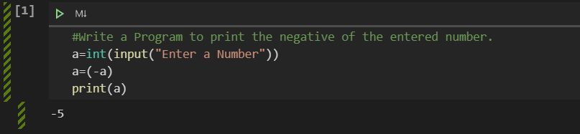

**Date:**